**L**inux

**A**pache

**M**ySQL/MariaDB

**P**HP

**C**ENTOS-7

**VERSIONS**

**$ hostnamectl = Centos 7**

**$ apachectl -v = APACHE 2.4.14**

**$ php --version = PHP 7.4.13**

**$ mysql --version = MariaDB 10.3.25**

**Author: Guillermo Hoyo Bravo**

**INDICE**

1 LAMP 3

2 Before Installing lamp in centos 7 4

2.1 Configure repositories EPEL 4

3 Install lamp server in centos 7 5

3.1 Download and install the packages 5

3.1.1 Firewall configuration 5

4 Configurar el Firewall UFW de Ubuntu 20 para la pila LAMP 6

4.1.1 Apache 6

4.2 Data Base Service 7

4.3 PHP 7

5 CHEck lamp correctly is working 9

# LAMP

LAMP is the acronym for Linux, Apache, MySQL / MariaDB, PHP.

It is an internet infrastructure system (Stack) that uses the following tools:

* Linux: acts as a free Unix-like operating system kernel for the web application.
* MariaDB: used as a relational database.
* Apache: used as a web server and open source.
* PHP: used to process dynamic content. It is a programming language designed to produce dynamic websites.

There are different variants in which it is used as MySQL or PostgreSQL databases. We assume that the user has a partition installed on their computer with Centos 7 and root access. To check our version of CentOS, we use the command:

$ lsb_release -a

# Before Installing lamp in centos 7

## Configure repositories EPEL

Install the necessary tools

$ sudo yum install –y install epel-release yum-utils

Configure PHP Repository

$ sudo yum install –y http://rpms.remirepo.net/enterprise/remi-release-7.rpm

Choosing 7.4 PHP version

$ sudo yum-config-manager --enable remi-php74

We could use any other version of php from the repository like: php 73 for php 7.3

Configure MariaDB Repository

$ sudo nano /etc/yum.repos.d/mariadb-10.4.repo

Add this content:

[mariadb]

name = MariaDB

baseurl = <http://yum.mariadb.org/10.4/centos7-amd64>

gpgkey=https://yum.mariadb.org/RPM-GPG-KEY-MariaDB

gpgcheck=1

Update Repositories

$ sudo yum update -y

# Install lamp server in centos 7

## Download and install the packages

Cheacking both

$ sudo yum -y install httpd mariadb-server php php-mysqlnd

Enable services to start on boot.

$ sudo systemctl enable httpd mariadb

Arranque de los servicios

$ sudo systemctl start httpd mariadb

### Firewall configuration

Add exception to services HTTP and HTTPS

$ sudo firewall-cmd --permanent --zone=public --add-service=http

$ sudo firewall-cmd --permanent --zone=public --add-service=https

Refresh the configuration to apply the changes

$ sudo firewall-cmd --reload

# Configurar el Firewall UFW de Ubuntu 20 para la pila LAMP

### Apache

Edit the configuration File

$ sudo nano /etc/httpd/conf/httpd.conf

Search the deactivated directive #Servername

Delete # to activate it and assign a value:

ServerName centos7.local:80

We can choose the name we want

Original Version  
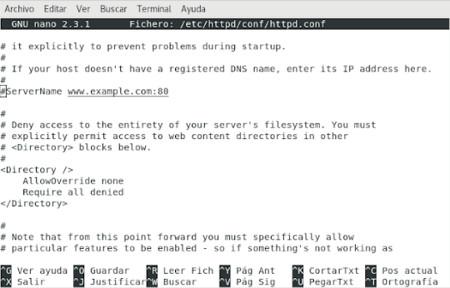

Modified Version

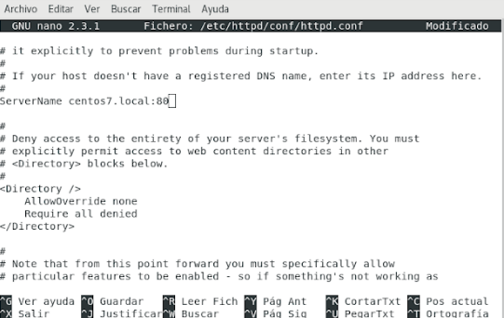

Save and reload the service to apply the changes.

$ sudo systemctl reload httpd

## Data Base Service

Secure Installation of MariaDB

$ sudo mysql_secure_installation

* Introduce actual Password: [PASSWORD]
* Change the autentification unix_socket [Y/n]: Y
* Change root password: [Y/n] Y

[PASSWORD]

[PASSWORD]

* Delete anonymous users: Y
* Disable remote root login: Y
* Delete Test Data Base and the access to it: Y
* Refresh privileges now: Y

## PHP

Edit php.ini

$ sudo nano /etc/php.ini

Changes to realice in secutial order:

...

error_reporting = E_ALL

...

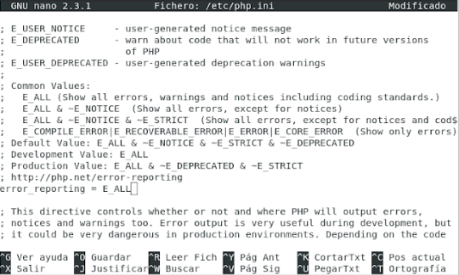

…

display_errors = On

...

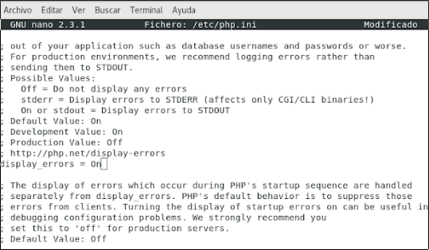

…

display_startup_errors = On

…

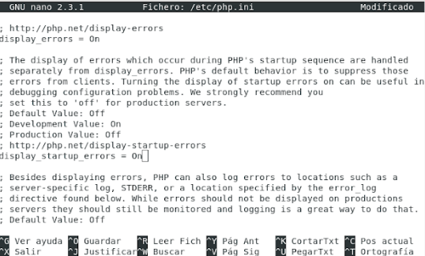

[Date]

; Defines the default timezone used by the date functions

; <http://php.net/date.timezone>

date.timezone = Europe/Madrid

…

To check your time zone: <http://php.net/manual/es/timezones.php>

Save and reload service to apply changes

$ sudo systemctl reload httpd

# Check lamp correctly is working

We are creating a small PHP script

$ sudo nano /var/www/html/info.php

Writte:

<?php phpinfo();

Obtain our IP direction by using the command:

$ hostnamectl

With this direction, we can access the page: IP/info.php

We can also do this with our server domain name: DomainName/info.php

This is the resoult that ensure us LAMP is working correctly:

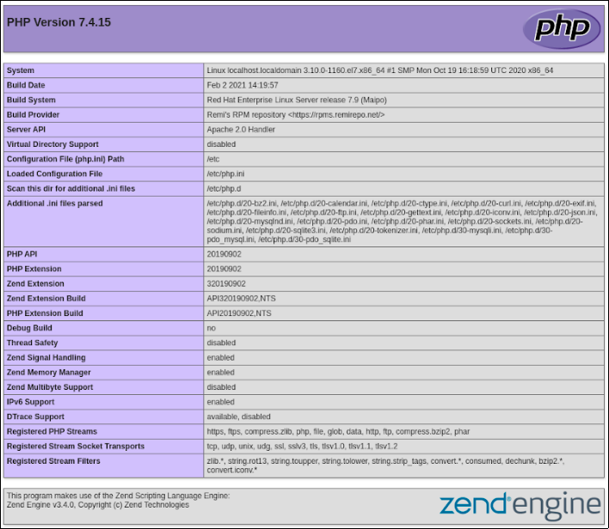

**REFETENCES**

INSTALL LAMP:

<https://comoinstalar.me/como-instalar-lamp-en-centos-7/>

BEFORE INSTALLING LAMP IN CENTOS 7

Configure repositories EPEL

Install the necessary tools.

$ sudo yum install –y install epel-release yum-utils

Configure PHP Repository

$ sudo yum install –y <http://rpms.remirepo.net/enterprise/remi-release-7.rpm>

Choosing 7.4 PHP version

$ sudo yum-config-manager --enable remi-php74

Podríamos usar cualquier otra como php73 para php 7.3

Configure MariaDB Repository

$ sudo nano /etc/yum.repos.d/mariadb-10.4.repo

Add this content:

[mariadb]

name = MariaDB

baseurl = <http://yum.mariadb.org/10.4/centos7-amd64>

gpgkey=https://yum.mariadb.org/RPM-GPG-KEY-MariaDB

gpgcheck=1

Update Repositories

$ sudo yum update -y

3 INSTALL LAMP SERVER IN CENTOS 7

Download and install the packages

Cheacking both

$ sudo yum -y install httpd mariadb-server php php-mysqlnd

Enable services to start on boot.

$ sudo systemctl enable httpd mariadb

Arranque de los servicios

$ sudo systemctl start httpd mariadb

Firewall configuration

Add exception to services HTTP and HTTPS

$ sudo firewall-cmd --permanent --zone=public --add-service=http

$ sudo firewall-cmd --permanent --zone=public --add-service=https

Refresh the configuration to apply the changes

$ sudo firewall-cmd --reload

4 CONFIGURAR EL FIREWALL UFW DE UBUNTU 20 PARA LA PILA LAMP

Apache

Edit the configuration File

$ sudo nano /etc/httpd/conf/httpd.conf

Search the deactivated directive #Servername

Delete # to activate it and assign a value:

ServerName centos7.local:80

We can choose the name we want

Original Version

Modified Version

Save and reload the service to apply the changes.

$ sudo systemctl reload httpd

Data Base Service

Secure Installation of MariaDB

$ sudo mysql_secure_installation

* Introduce actual Password: [PASSWORD]
* Change the autentification unix_socket [Y/n]: Y
* Change root password: [Y/n] Y

[PASSWORD]

[PASSWORD]

* Delete anonymous users: Y
* Disable remote root login: Y
* Delete Test Data Base and the access to it: Y
* Refresh privileges now: Y

PHP

To check your time zone: <http://php.net/manual/es/timezones.php>

Edit php.ini

$ sudo nano /etc/php.ini

CHANGES:

...

[Date]

; Defines the default timezone used by the date functions

; <http://php.net/date.timezone>

date.timezone = Europe/Madrid

...

error_reporting = E_ALL

...

display_errors = On

...

display_startup_errors = On

Save and reload service to apply changes

~$ sudo systemctl reload httpd

CHECK LAMP CORRECTLY IS WORKING

We are creating a small PHP script

$ sudo nano /var/www/html/info.php

WRITTE

<?php phpinfo();

Obtain our IP direction by using the command:

$ hostnamectl

With this direction, we can access the page: IP/info.php

We can also do this with our server domain name: DomainName/info.php

This is the resoult that ensure us LAMP is working correctly:

**REFETENCES**

INSTALL LAMP:

<https://comoinstalar.me/como-instalar-lamp-en-centos-7/>